STEP BY STEP ON HOW TO INSTALL CHROME AND PYCHARM ON UBUNTU 16.04

Ways to Install Google Chrome on Ubuntu 16.04 and Ubuntu 17.10

Go to https://www.google.com/chrome. Click the Download Chrome button.
- Click on download chrome
- Select your download page 64bit.deb
- Then click on Accept and download

When Firefox asks you how to open this deb file, choose the default option to open it in Ubuntu Software (formerly Ubuntu Software Center).

- Select open with and press ok

if you choose the first option, Google Chrome deb package will be downloaded to /tmp/mozilla_$username directory. Once the download is complete, Ubuntu Software will automatically open. Click the Install button to install google-chrome-stable to Ubuntu 16.04/17.10. The version and installation size information can be seen in the Details section. 189.4MB of disk space! That’s huge for a Web browser

- Then click install

Because software installation on Linux requires root privilege, so you have to enter your password to authenticate.

- Then type yr password

Once the installation is complete, you can start Chrome browser in the Unity Dash or by typing the following command in the terminal.
google-chrome-stable
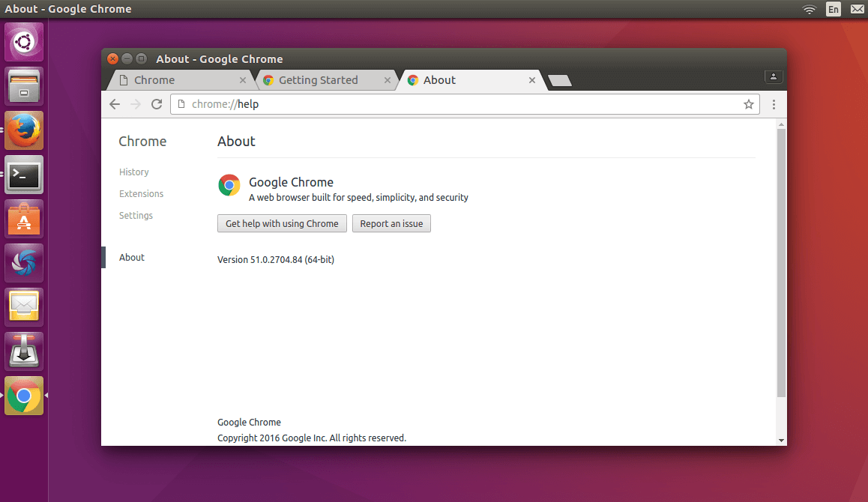

Install Google Chrome on Ubuntu 16.04 LTS/Ubuntu 17.10 from the Command Line

For those of you who like to hone their command line skills, here is how to install Google Chrome on Ubuntu 16.04/17.10 using terminal.
Press CTRL+ALT+T to open a terminal window, then edit sources.list file with nano text editor. You need to enter your password.
- sudo nano /etc/apt/sources.list
Use the down arrow key to scroll to the bottom of this file. Copy the following APT line and paste it at the end of the file.
deb [arch=amd64] http://dl.google.com/linux/chrome/deb/ stable main

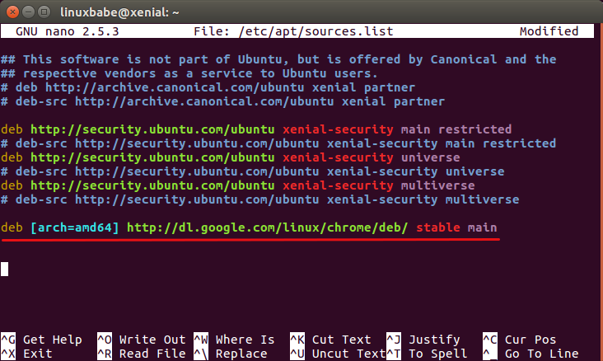
To save the file in Nano text editor, press Ctrl+O, then press Enter to confirm. Next, press CTRL+X to exit out of this file. After that, enter the following command to download Google’s signing key.
wget https://dl.google.com/linux/linux_signing_key.pub

Then use apt-key to add it to your keyring so the package manager can verify the integrity of Google Chrome package.
- sudo apt-key add linux_signing_key.pub
Now update package list and install the stable version of Google Chrome.
- sudo apt update

- sudo apt install google-chrome-stable
If you want to install the beta or unstable version of Google Chrome, use the following commands:
- sudo apt install google-chrome-beta

- sudo apt install google-chrome-unstable
Google Chrome browser Linux version ships with a built-in flash player called Pepper Flash installed under /opt/google/chrome/PepperFlash directory.
You may see the following warning message when issuing sudo apt update command.
Target Packages (main/binary-amd64/Packages) is configured multiple times
That’s because the Google Chrome package created an APT line in file /etc/apt/sources.list.d/google-chrome.list. You can remove the warning message by deleting that file.
- sudo rm /etc/apt/sources.list.d/google-chrome.list
As you can see, installing Google Chrome browser on Ubuntu 16.04 is easy! As always, if you found this post useful, then subscribe to our free newsletter. You can also follow us on Google+, Twitter or like our Facebook page.
Rate this tutorial

&

HOW TO INSTALL PYCHARM ON UBUNTU 16.04 / 17.10 AND 18.04

STEP 1: INSTALL SNAP PACKAGE MANAGEMENT
Snap is a new way and better way to install packages on Ubuntu… It’s quick and easy and provides better package management support…
Ubuntu 17.10 and 18.04 may already have Snap package management installed…. so you may not have to run the commands below… However, on Ubuntu 16.04 desktops, you will have to run the commands below to install Snap package management.
- sudo apt install snapd snapd-xdg-open
After running the above commands, continue below to install PyCharm…

STEP 2: INSTALL PYCHARM
Now that Snap is installed, run the commands below to install the version you want… to install the free community version, run the commands below
- sudo snap install pycharm-community --classic
To install the professional version, you run the commands below
- sudo snap install pycharm-professional --classic
That will do it… You can also use Ubuntu Software app to install PyCharm… open Ubuntu Software from the Activities Overview and search for PyCharm

STEP 3: INSTALL PYCHARM VIA UBUNTU SOFTWARE CENTER
If you can’t install PyCharm using the commands line above, open Ubuntu Software center and search for PyCharm… then select and install the edition you want to use…
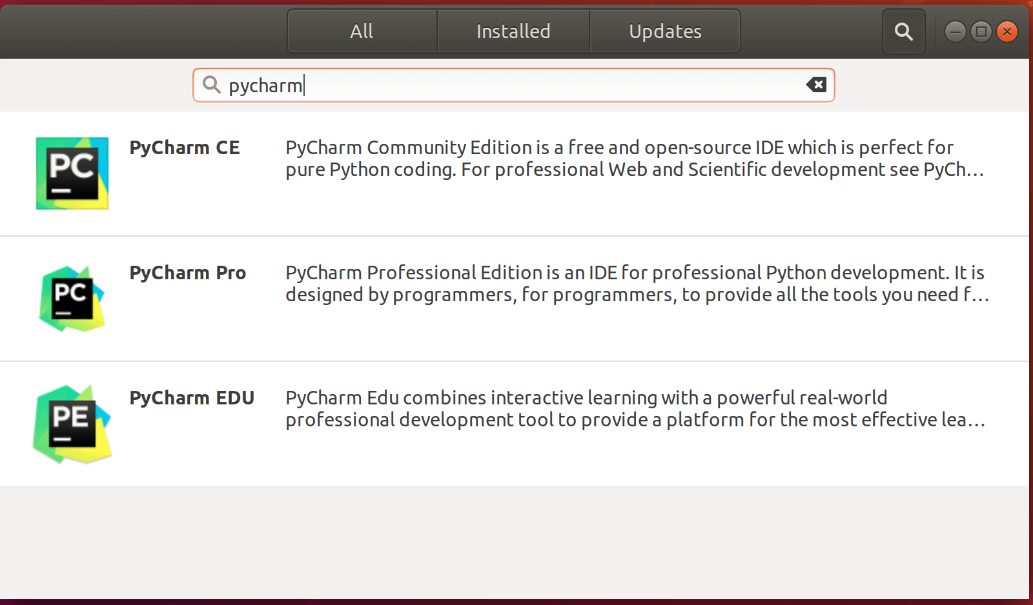
Then select and install the edition you want to use…
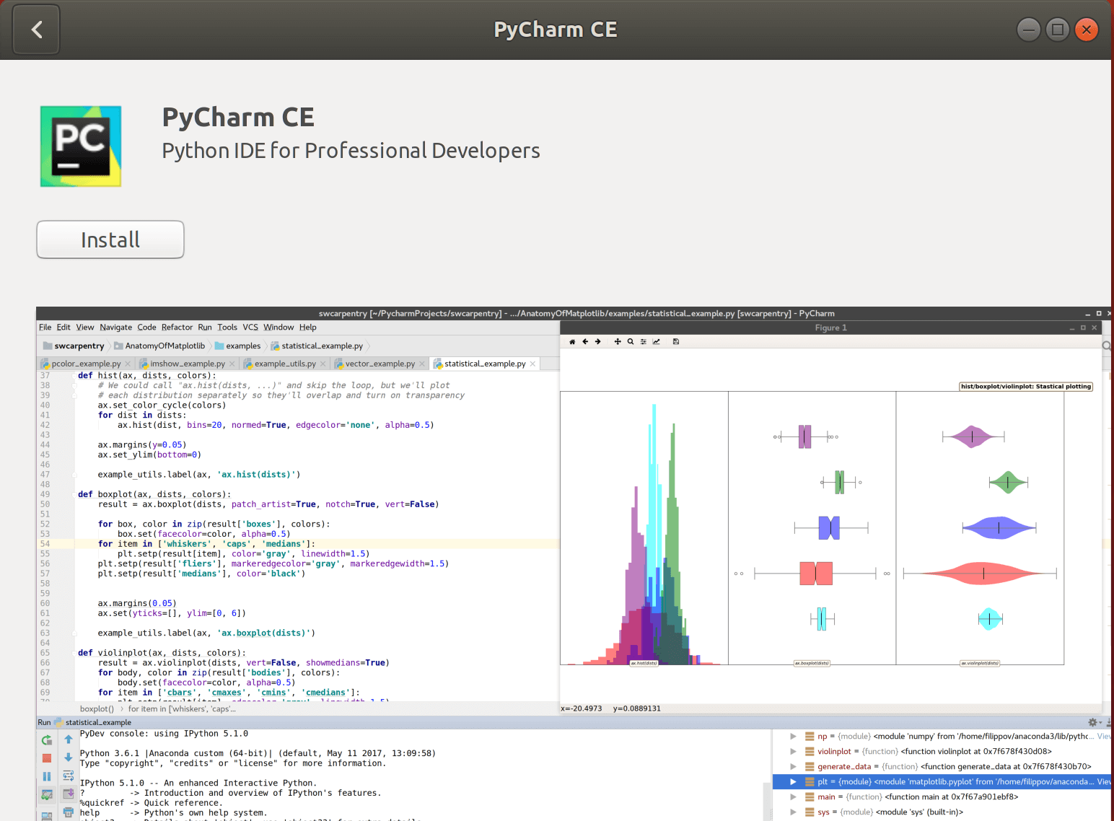
After installing, launch and start using PyCharm…
That’s it!

